Project – 3

**Deploying of Flask/Python Web applications in AWS Cloud.**

* What is a Flask?

**Ans:** Flask is a **web development framework** developed in Python. It iseasy to learnand use*.* Flask is a small and lightweight Python web framework that provides useful tools and features that make creating web applications in Python easier. It gives developers flexibility and is a more accessible framework for new developers since we can build a web application quickly using only a single Python file.

* What is a Python?

**Ans:** Python is a high-level, general-purpose programming language. Python is often used to build websites and software, automate tasks, and conduct data analysis.

* What is a PIP?

**Ans:** PIP is a package-management system written in Python and is used to install and manage software packages.

🡪 Pre-requisites:

1. Aws account

2. VPC

3. Ec2 Instance

4. GitHub

5. Git Bash / Terminal

6. Basic understanding of Python/Flask

7. Terraform

8. Jenkins

**🡪 Workflow:**

**PART 1 – Execute python application along with pre-requisites and check the output in the browser.**

1.Create an EC2 Instance (Ubuntu) with Default configuration (Free Tier).

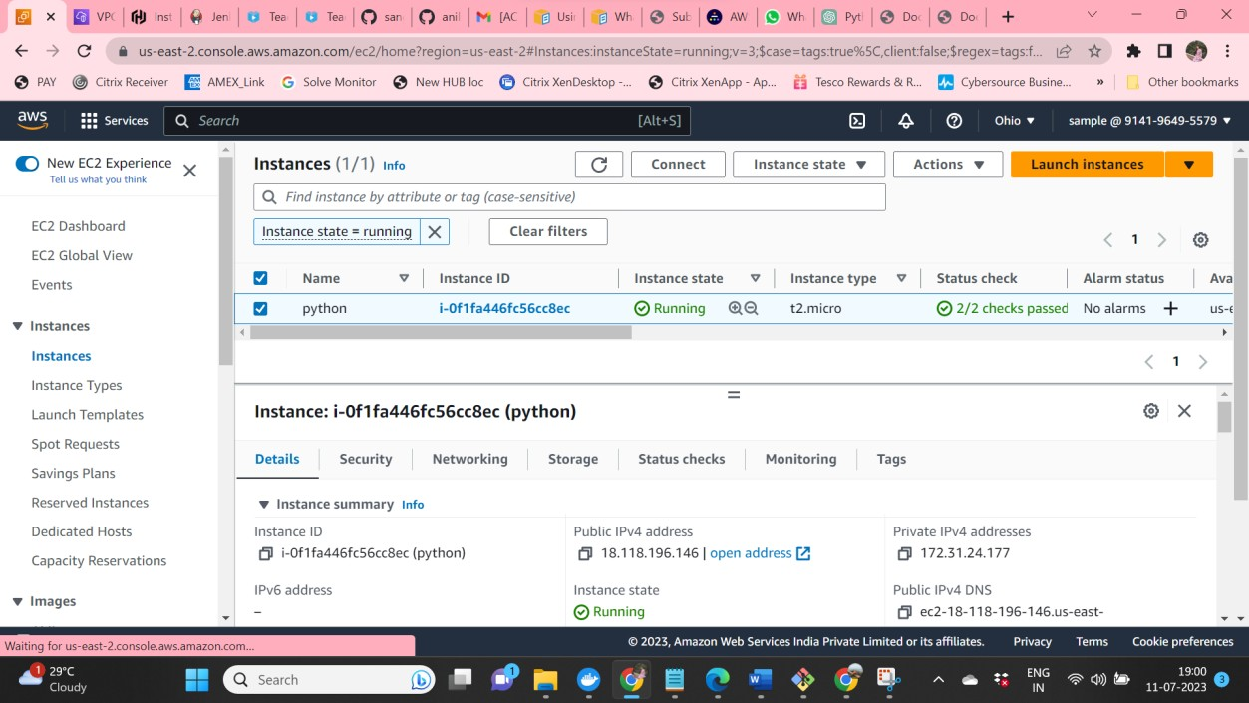

2.Security Group --> Port no --> SSH - 22, HTTP - 80, TCP - 8080, 5000, 7000

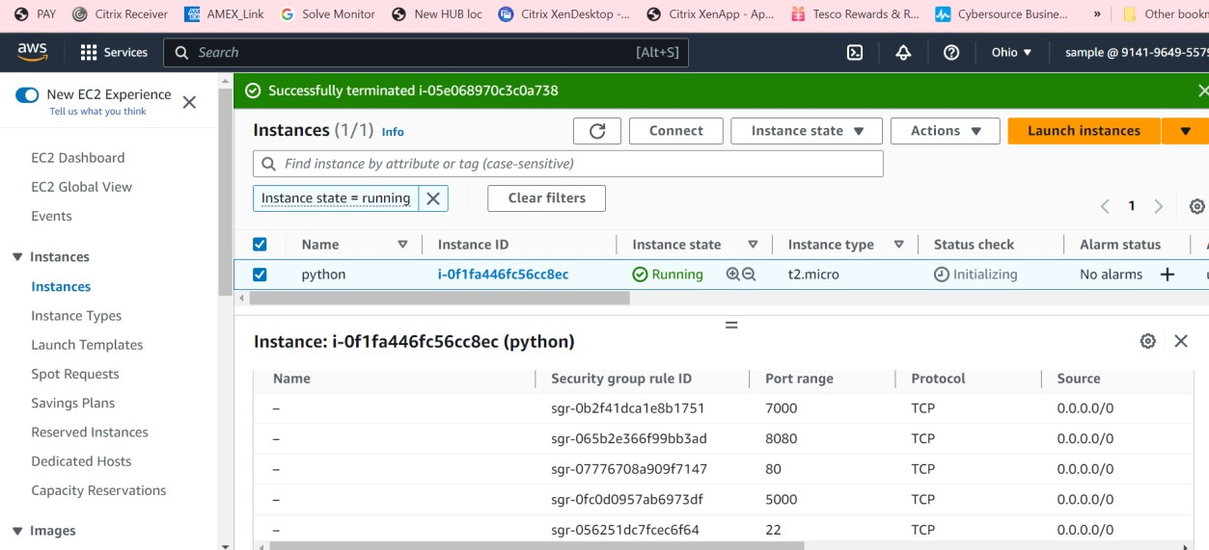

3.Connect to EC2 Instance by using GitBash.

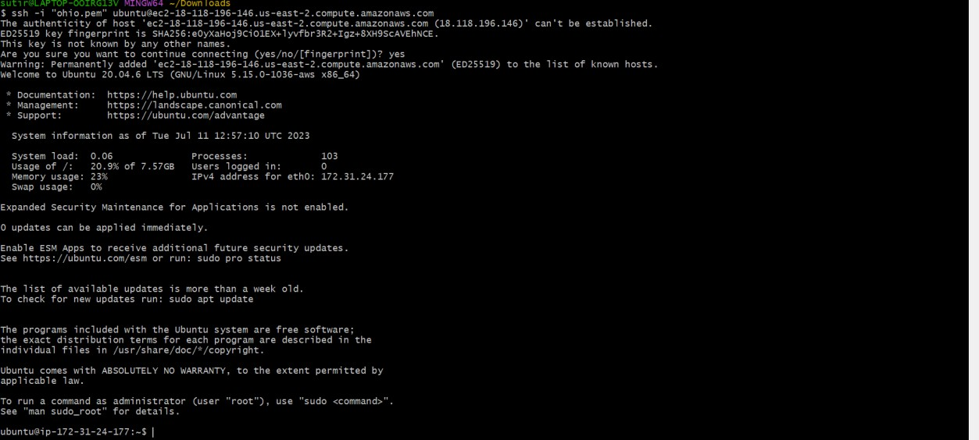

4.Update Ubuntu machine.

* sudo apt-get full-upgrade -y
* sudo apt update

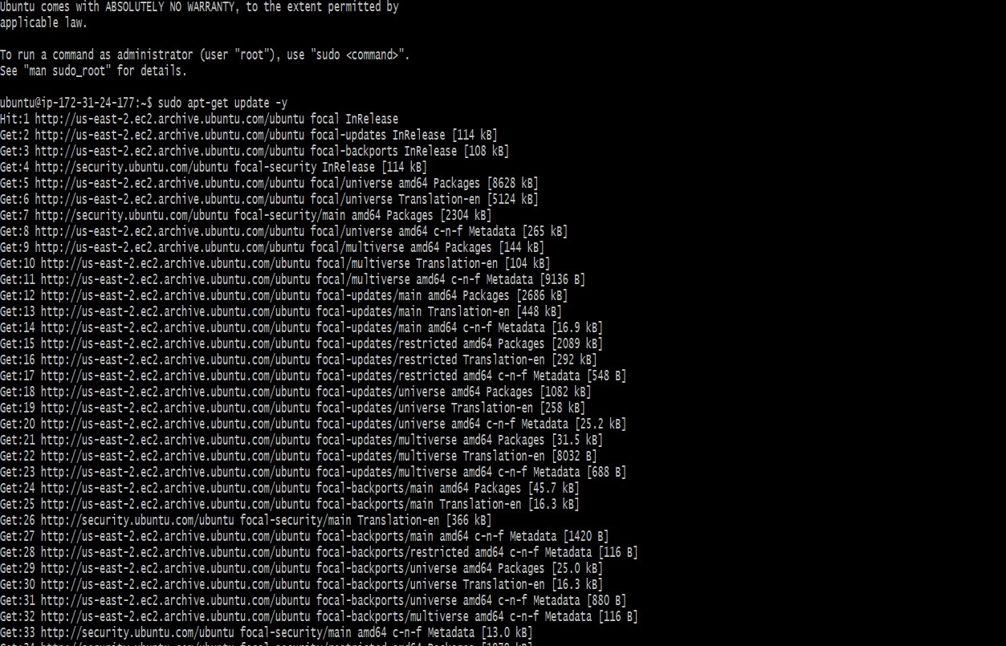

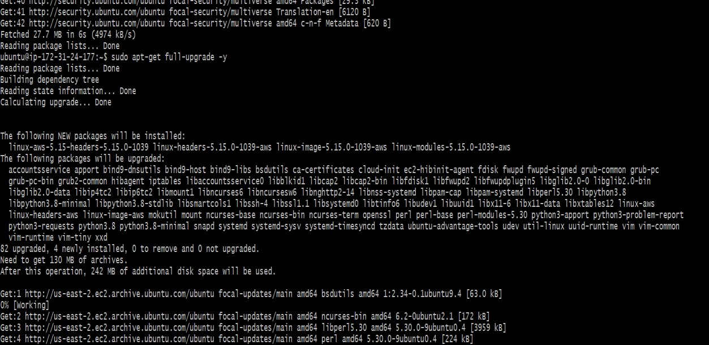

5.Install required packages/tools related for deployment project.

* sudo apt-get install python3-pip

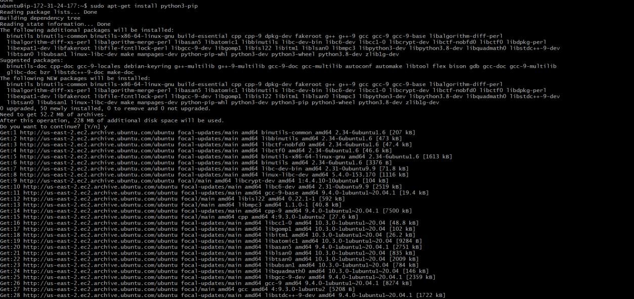

6.Clone the project source code from GitHub to your machine (Ubuntu EC2 Instance)

* git clone https://github.com/ranjithvenugopal98/car-prediction.git
* go to the source code directory cd car-prediction—new setup virtual environment in our local machine
* sudo apt install python3-virtualenv
* virtualenv carpred

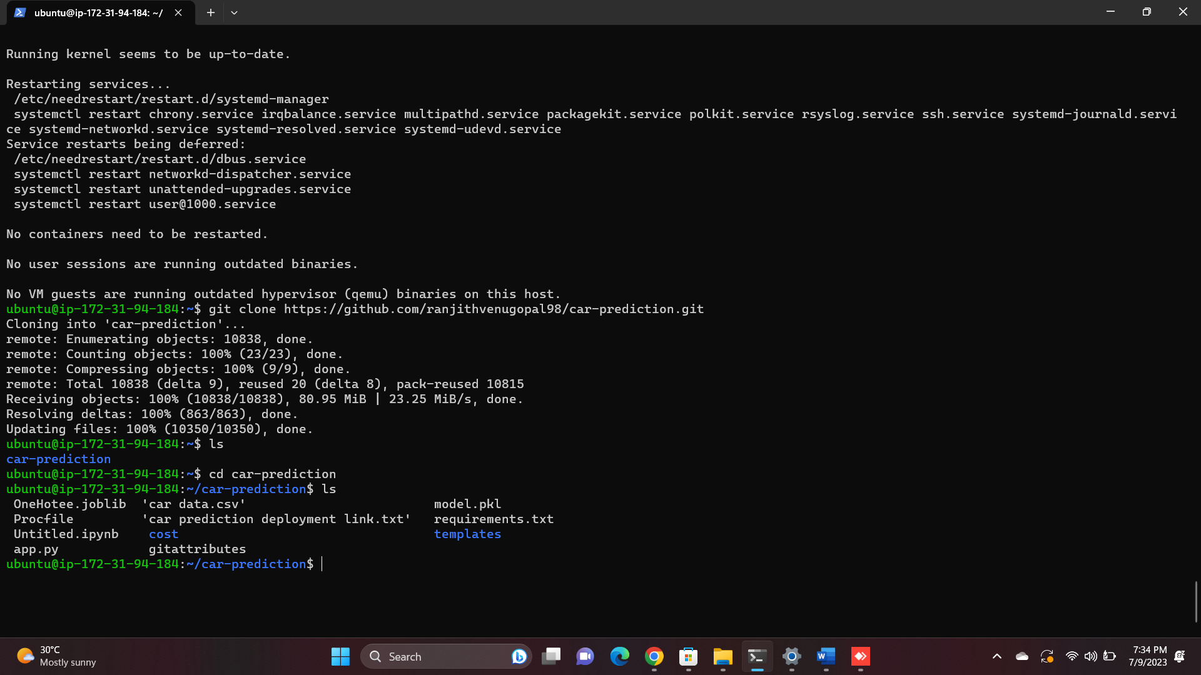

7.Now, Activate Virtual Environment by using below command

* source carpred/bin/activate Now, Install Requirements Packages
* pip install -r requirements.txt

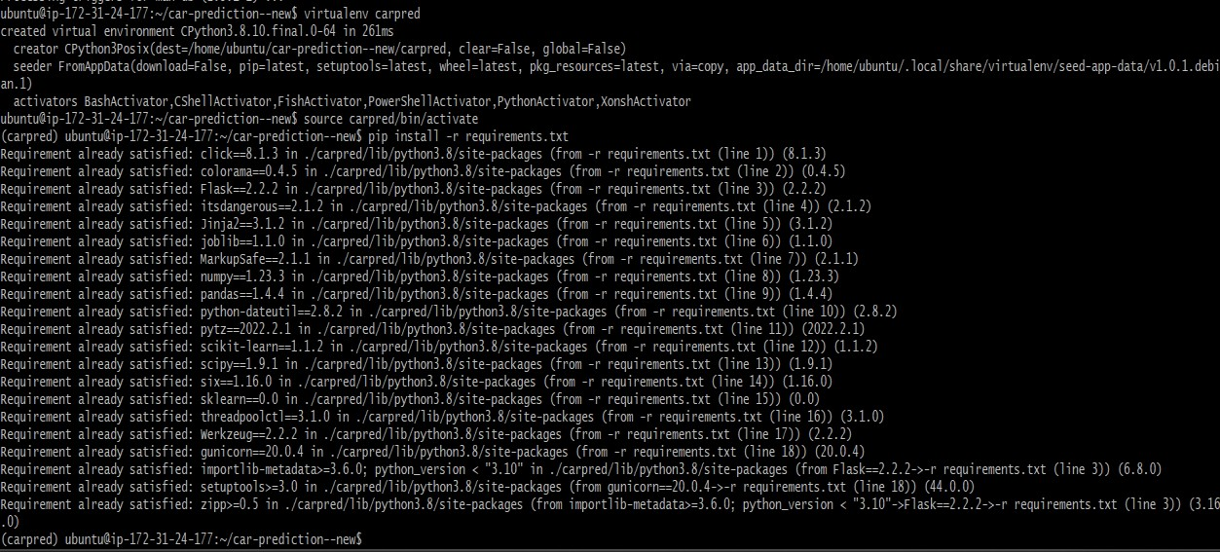

8.Run Flask Server python app.py

Here, after running python app.py, it will generate localhost IP address. We can’t access web app with that IP address

Therefore, we need to edit the file app.py with some details

* sudo vi app.py
* app.run(host='0.0.0.0', port=7000)

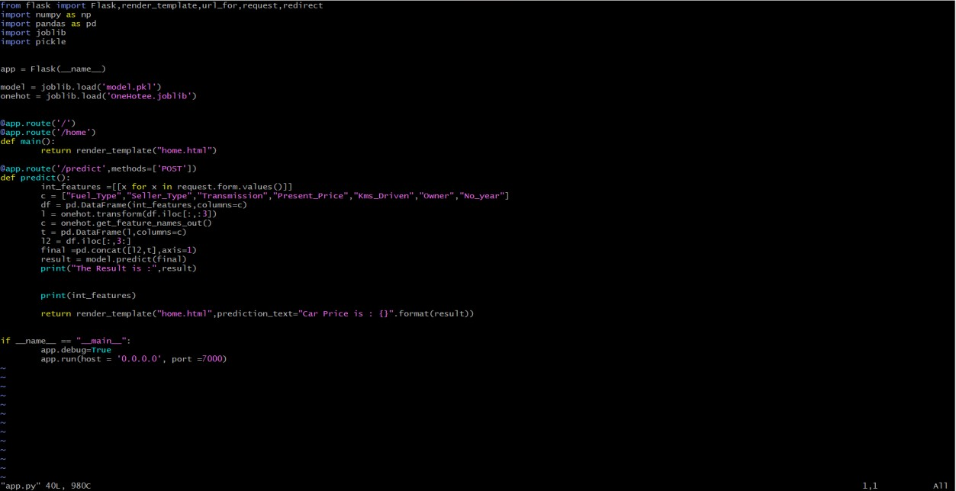

9.Now, again run the flask server by using below command

* python3 app.py

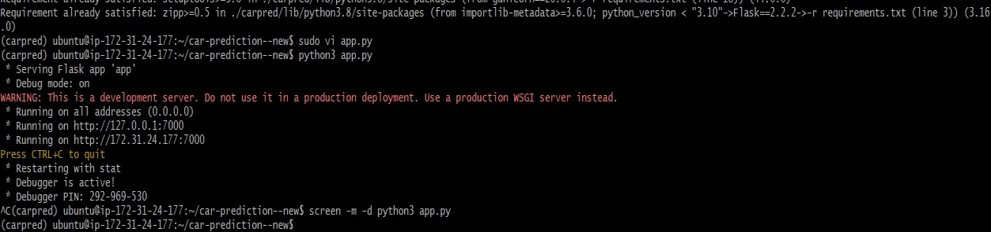

10.In order to continuously monitor python application in detach mode we give the below command

* screen -m -d python3 app.py

11.Now browse the public IP address from the instance and assign the port number which we have given.

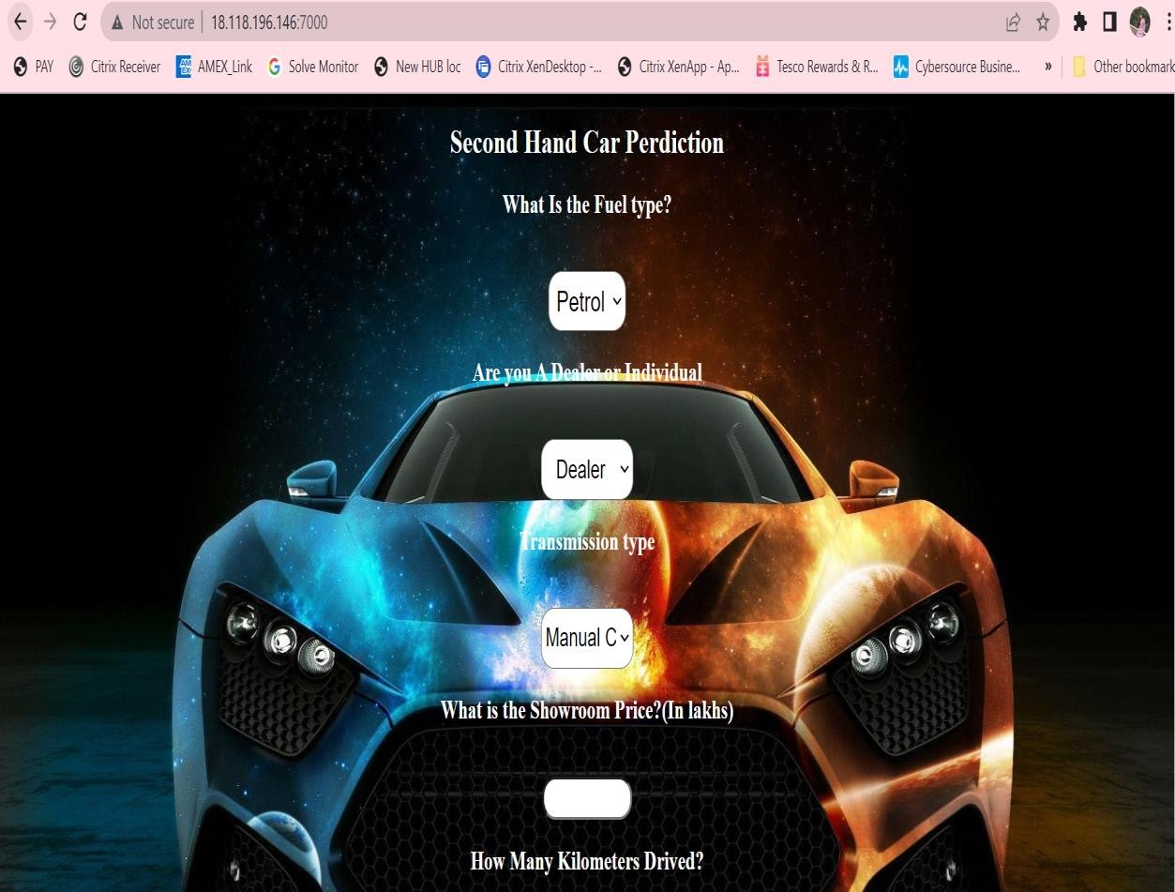

# PART 2 – Create user data, terraform files and browse the output of the python application.

Step 1 : Create EC2 instance with default VPC

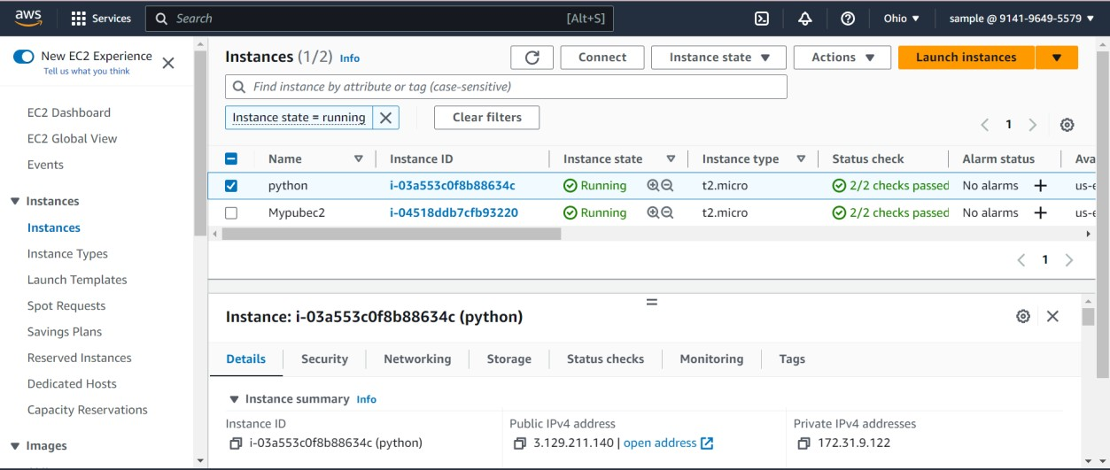

Step 2: Create terraform-config.txt file, provide permission and execute the file. Commands present in the terraform-config.txt file :

* sudo yum install -y yum-utils
* sudo yum install -y yum-utils

<https://rpm.releases.hashicorp.com/AmazonLinux/hashicorp.repo>

* sudo yum -y install terraform

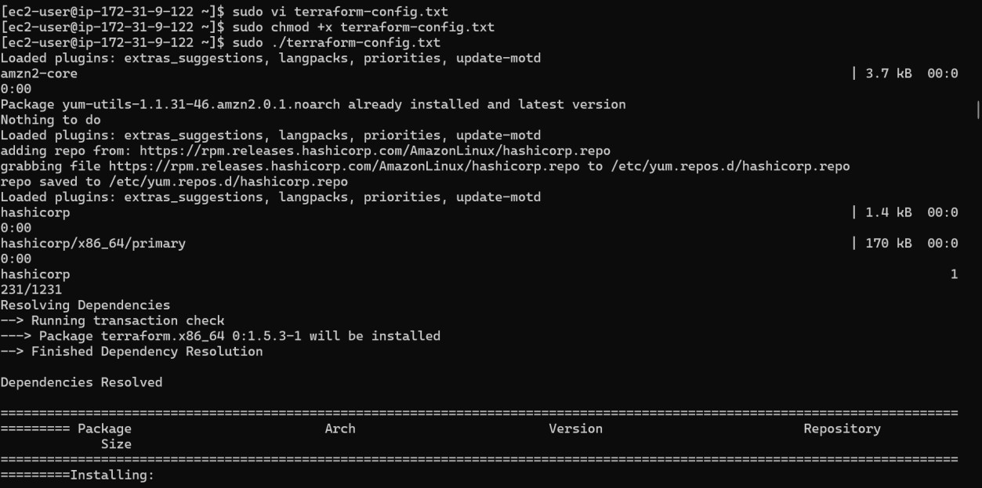

Step 3 : Building AWS infrastructure using Terraform (.tf)

1.provider.tf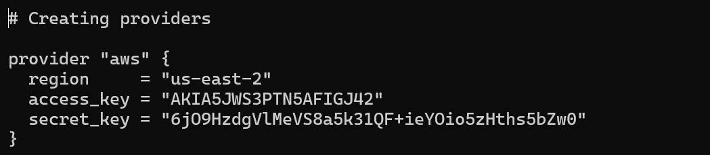

2.vpc.tf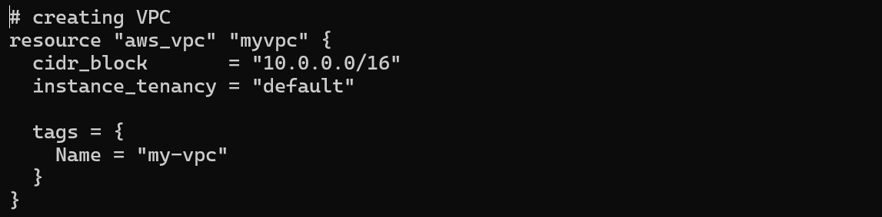3.igw.tf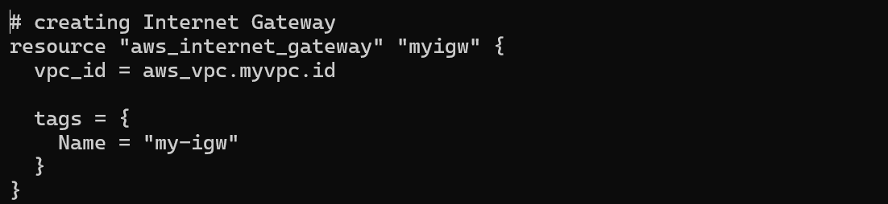

4.subnet.tf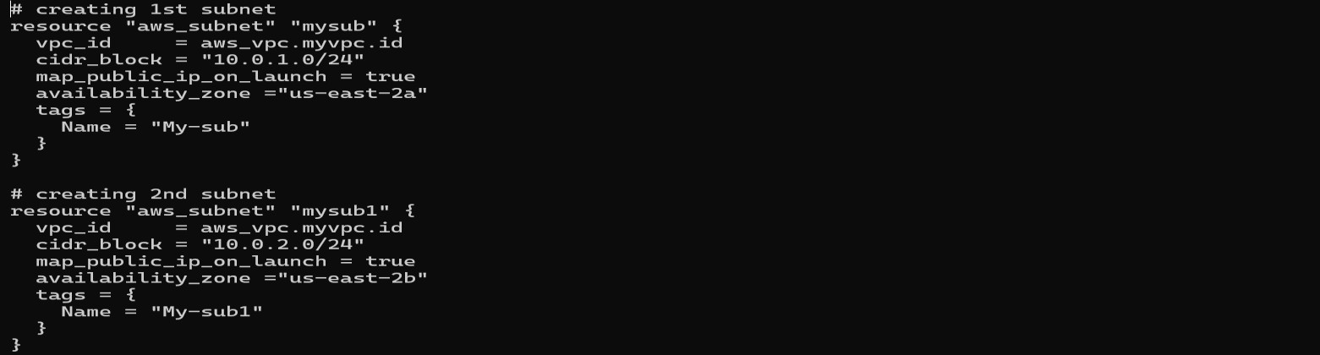

5.route_table.tf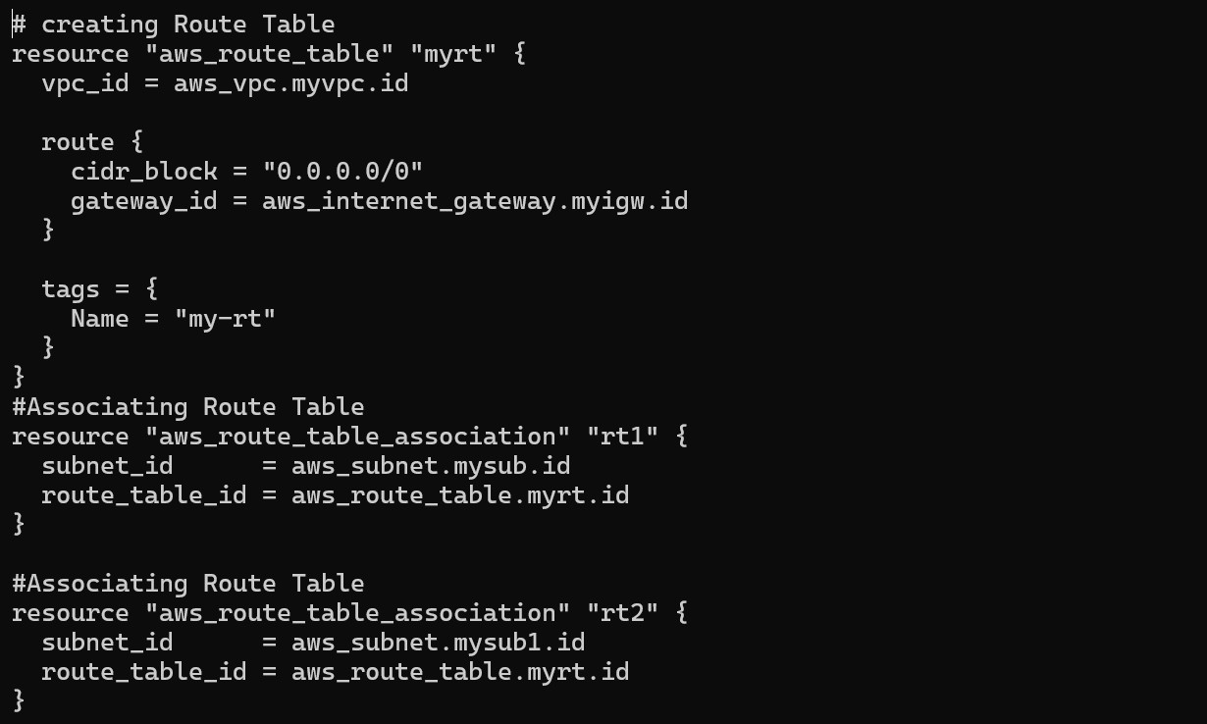

6.web_sg.tf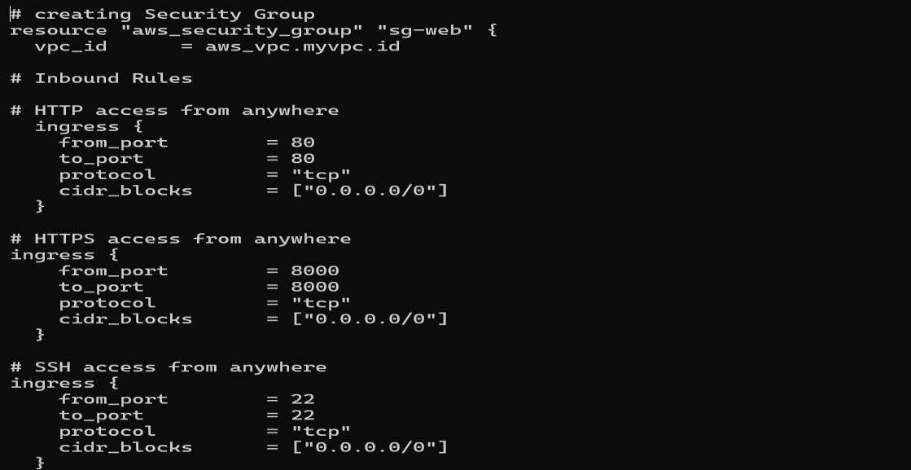

7.ec2.tf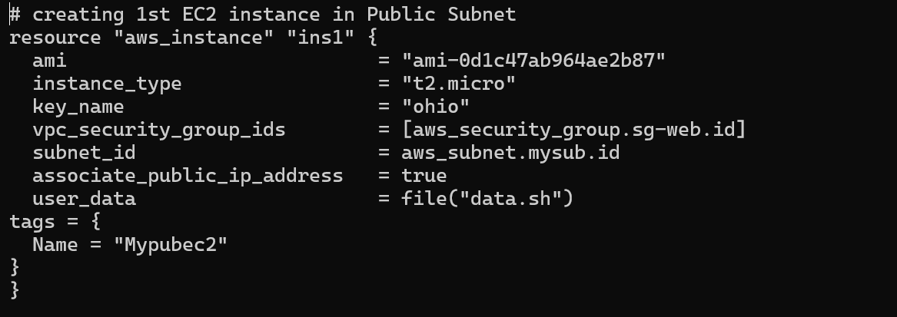

8.data.sh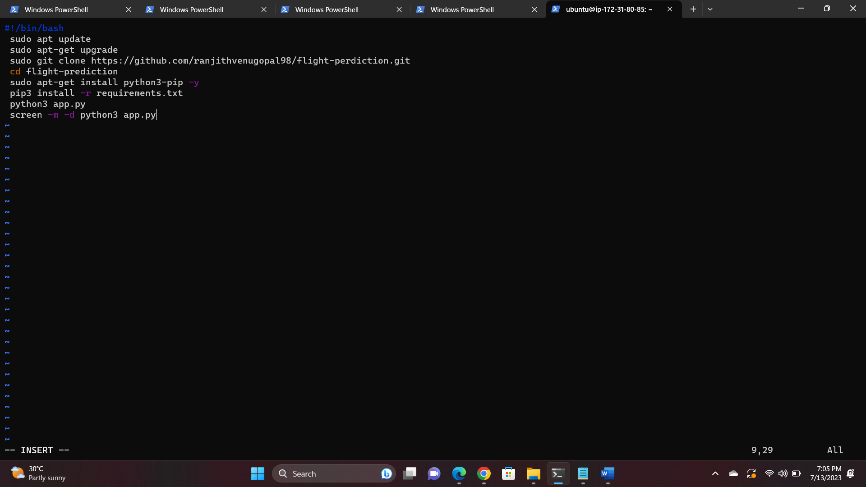

Applying terraform commands

* Terraform init
* Terraform validate
* Terraform plan
* Terraform apply –auto-approve

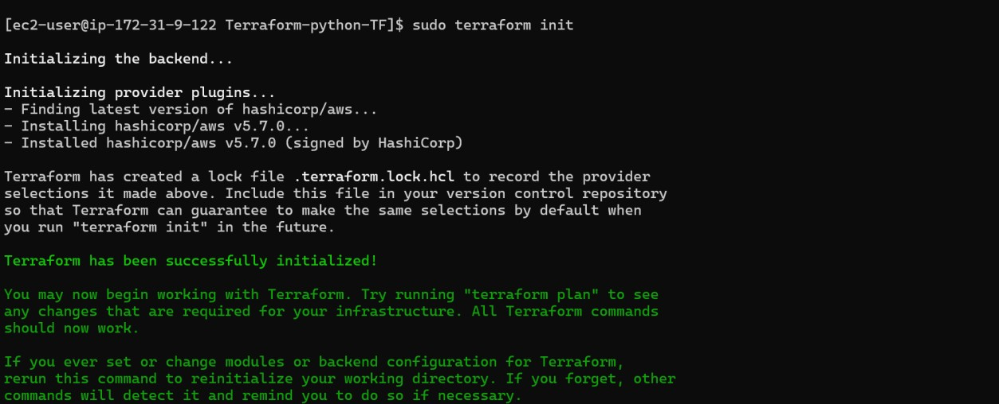

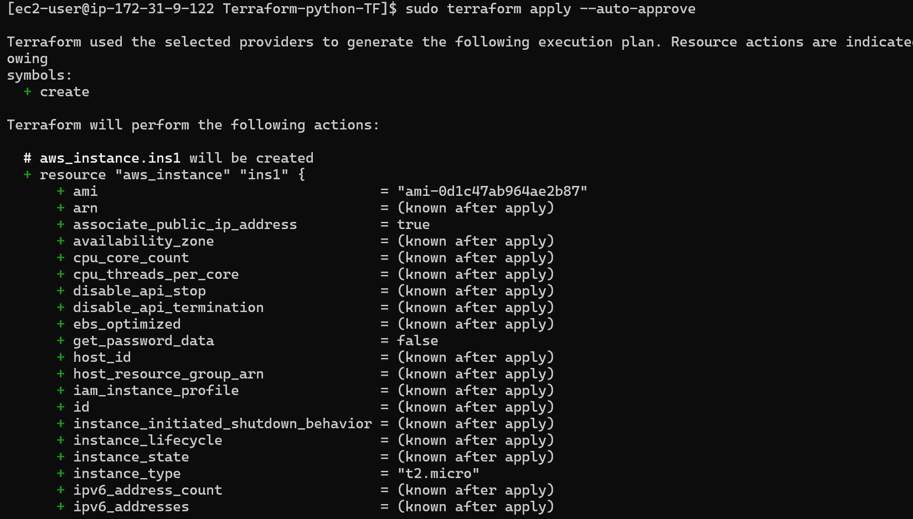

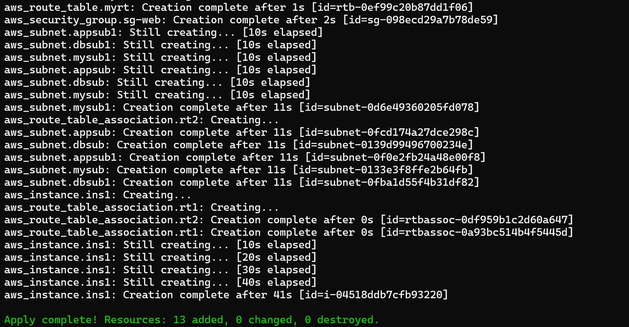

Step 4 : Check the infrastructure created

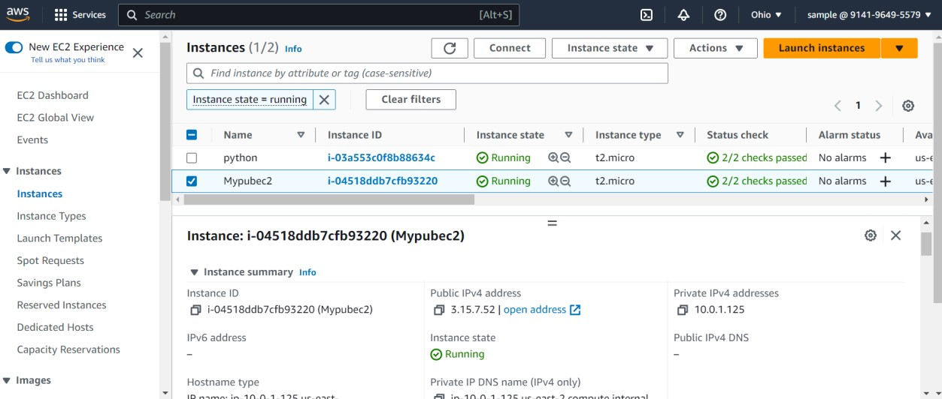

Step 5 : Browse the public IP address and use the assigned port number to search in the web browser.

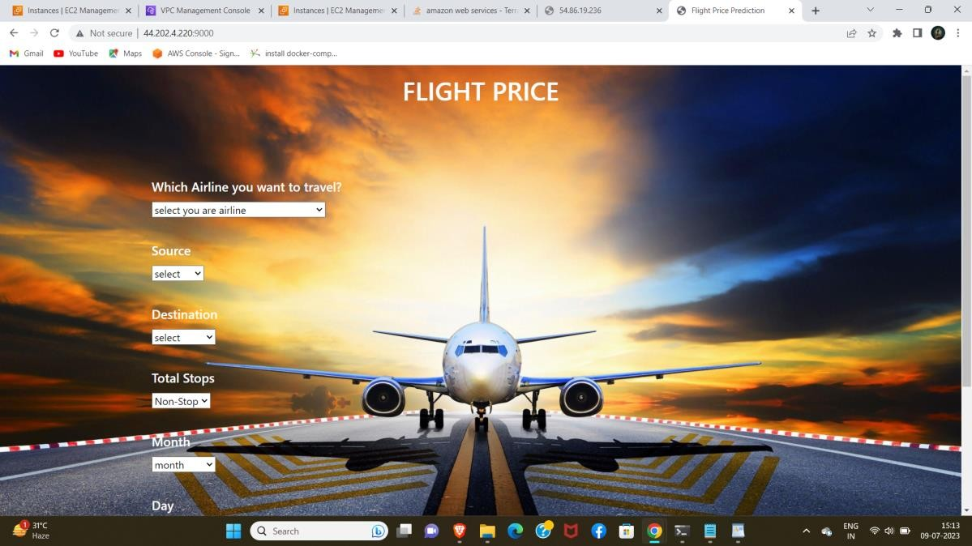

**PART 3 – Create and install Jenkins test, build and deploy application, browse the same in the browser.**

1.Create an EC2 instance and install Jenkins to test, build and deploy the application.

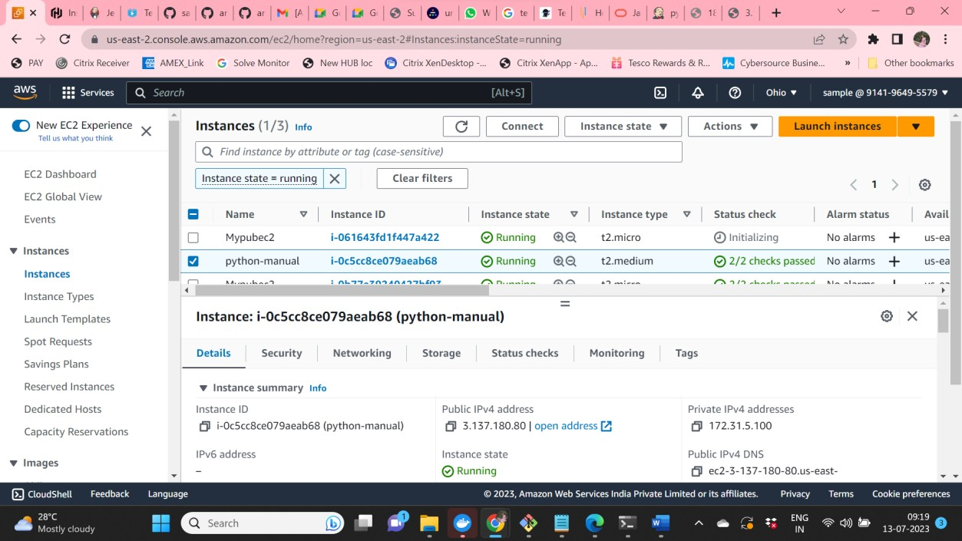

2.Install Java, Jenkins and Git

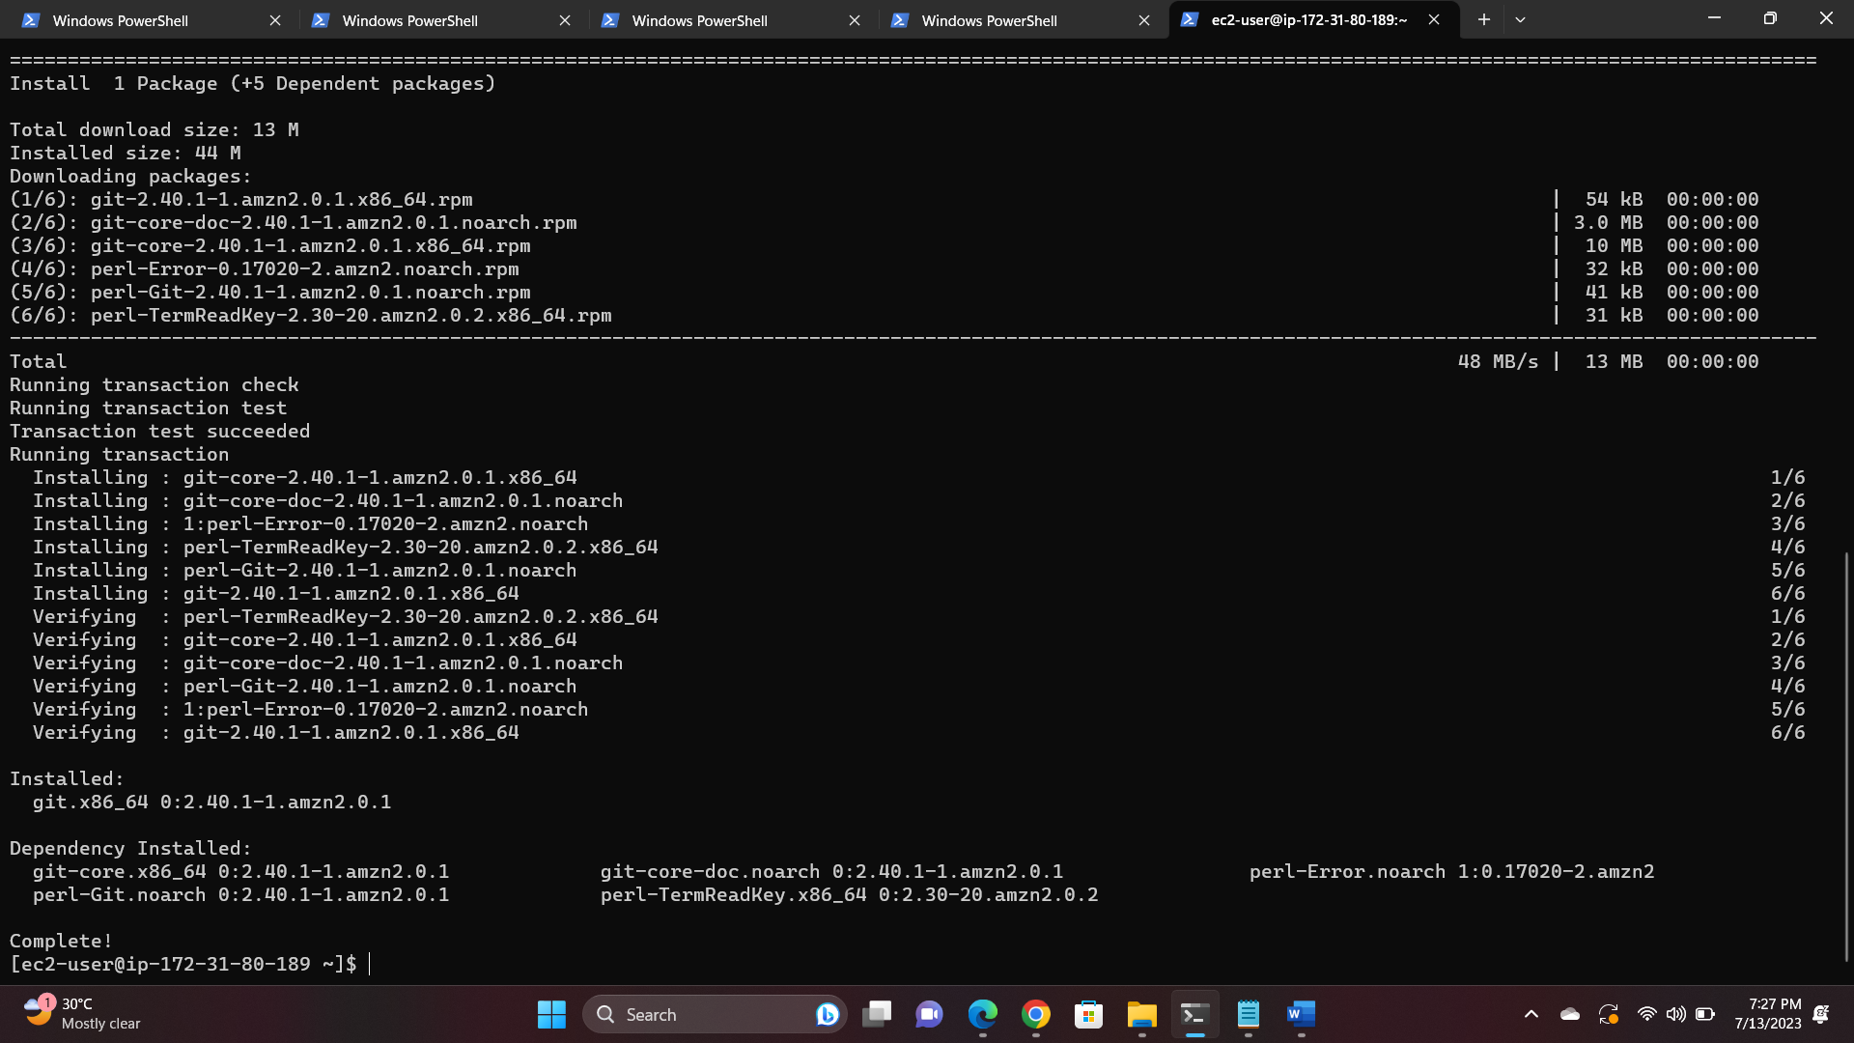

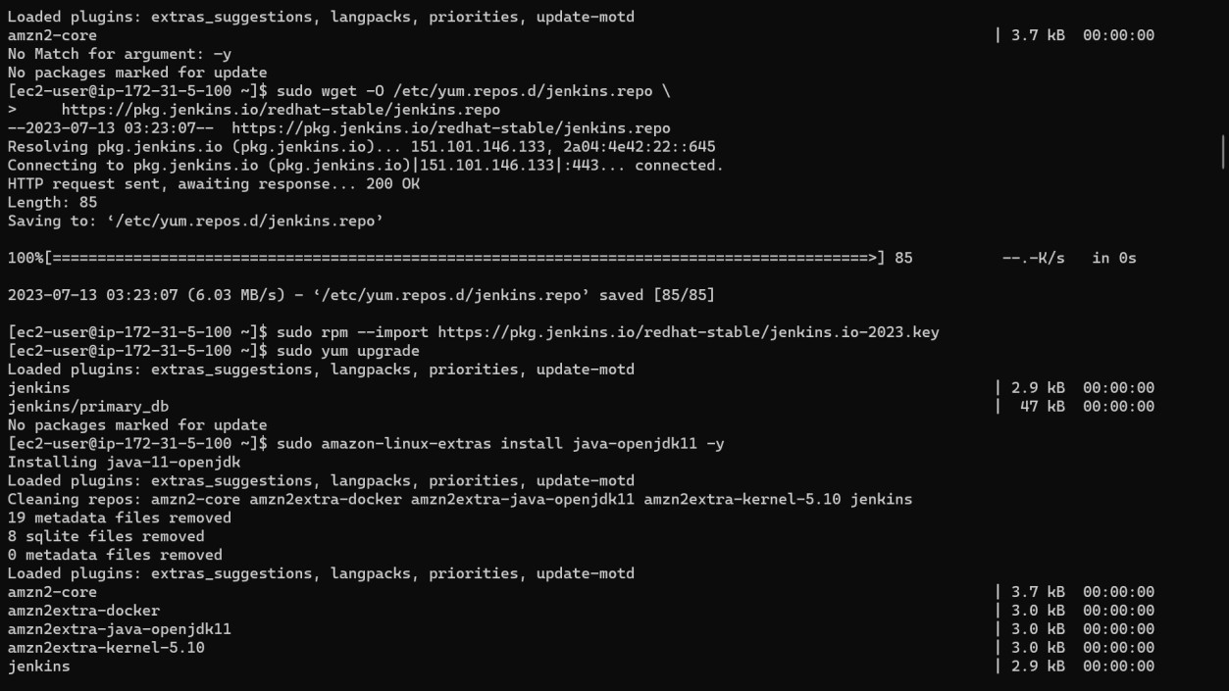

3.Start and enable Jenkins

* + sudo systemctl enable Jenkins
  + sudo systemctl start Jenkins
  + sudo systemctl status Jenkins

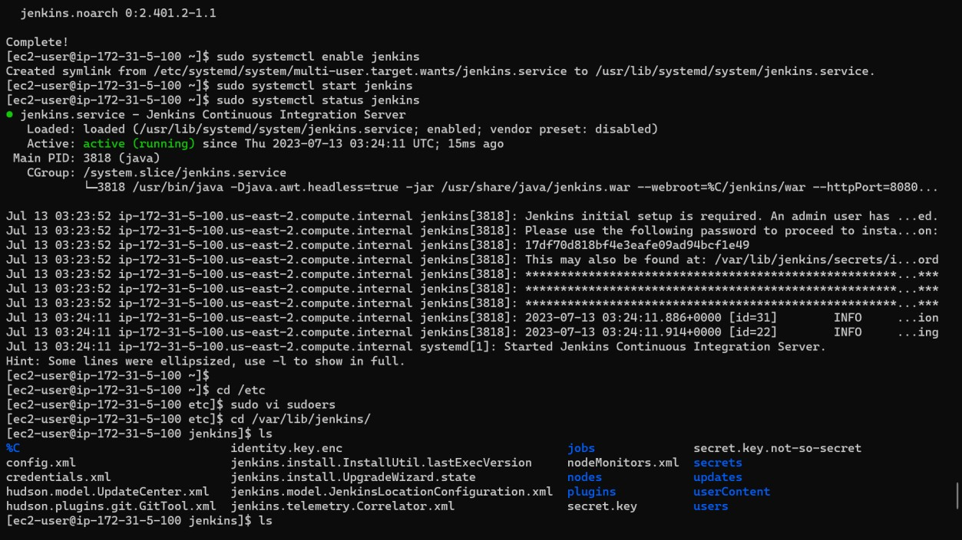

4.Browse IP, provide the password and install Jenkins page

5.Provide Jenkins password permissions in terminal and use cd /etc

6.Open vi sudoers and give permissions

7.Now open Jenkins and create a new job **“python-automation”**

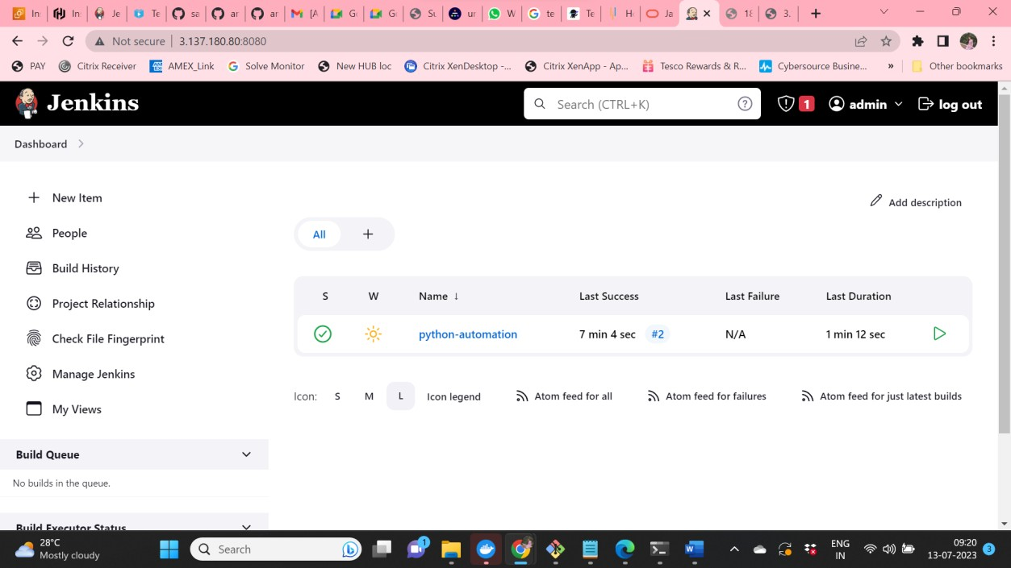

8.Add repo and credentials , also give commands in execute shell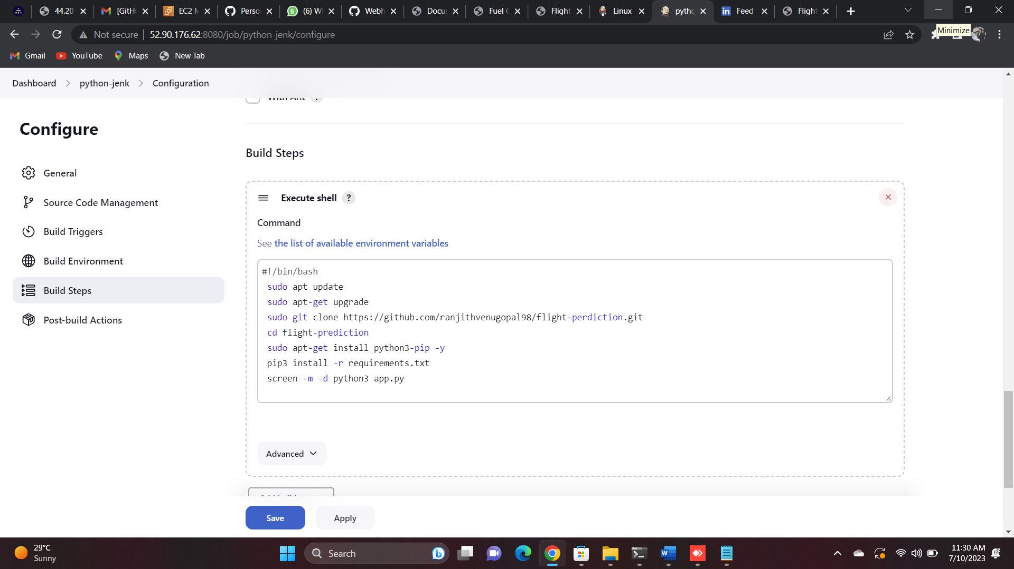

9.Now build the job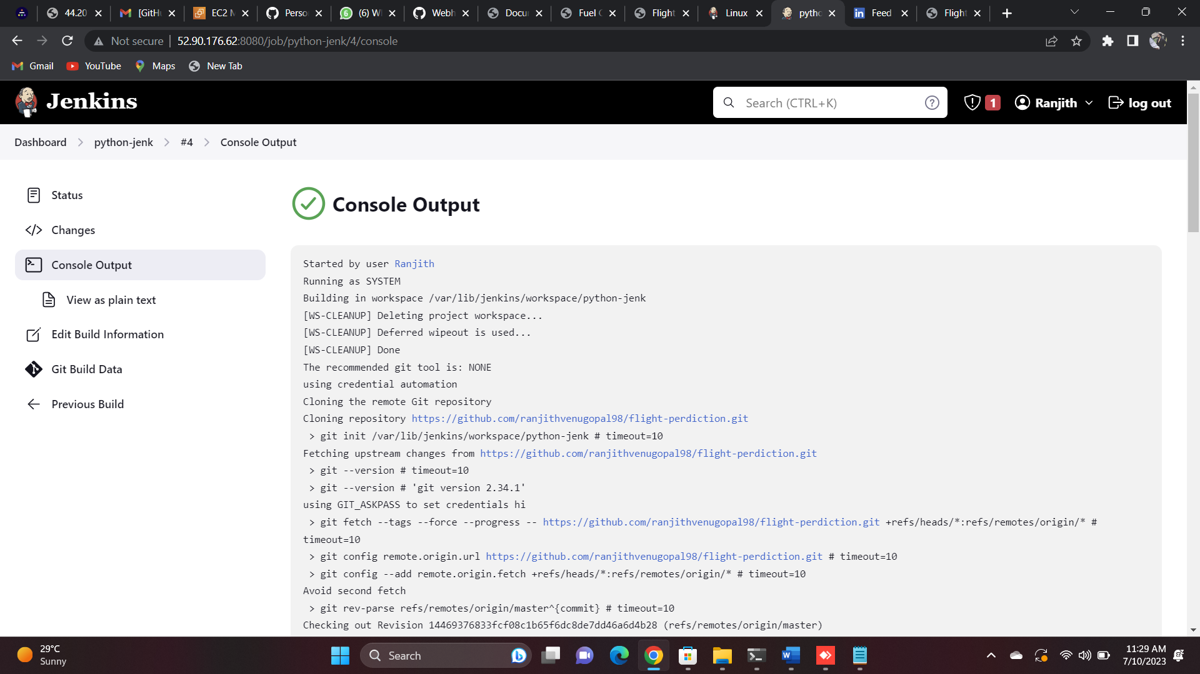

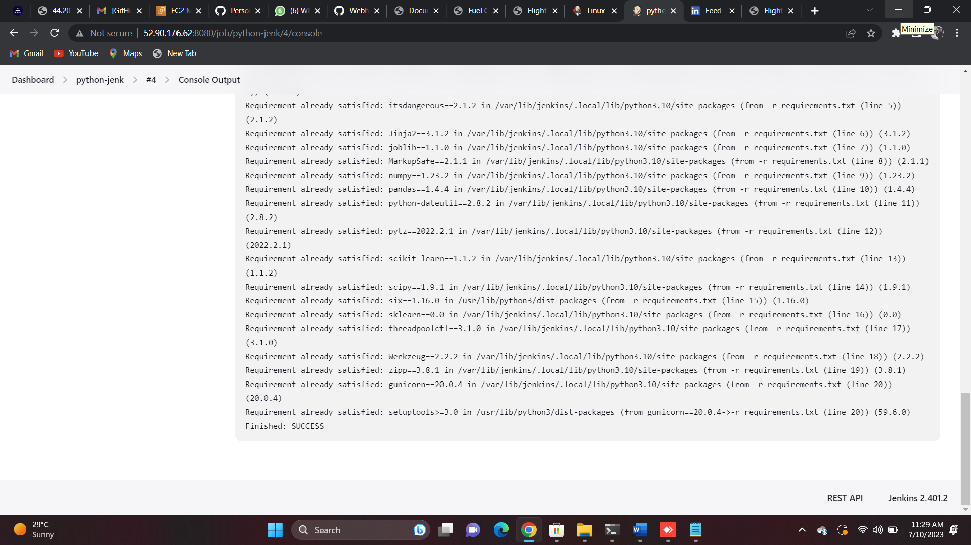

10. Browse the Public IP address and use the assigned port number to search in the web browser

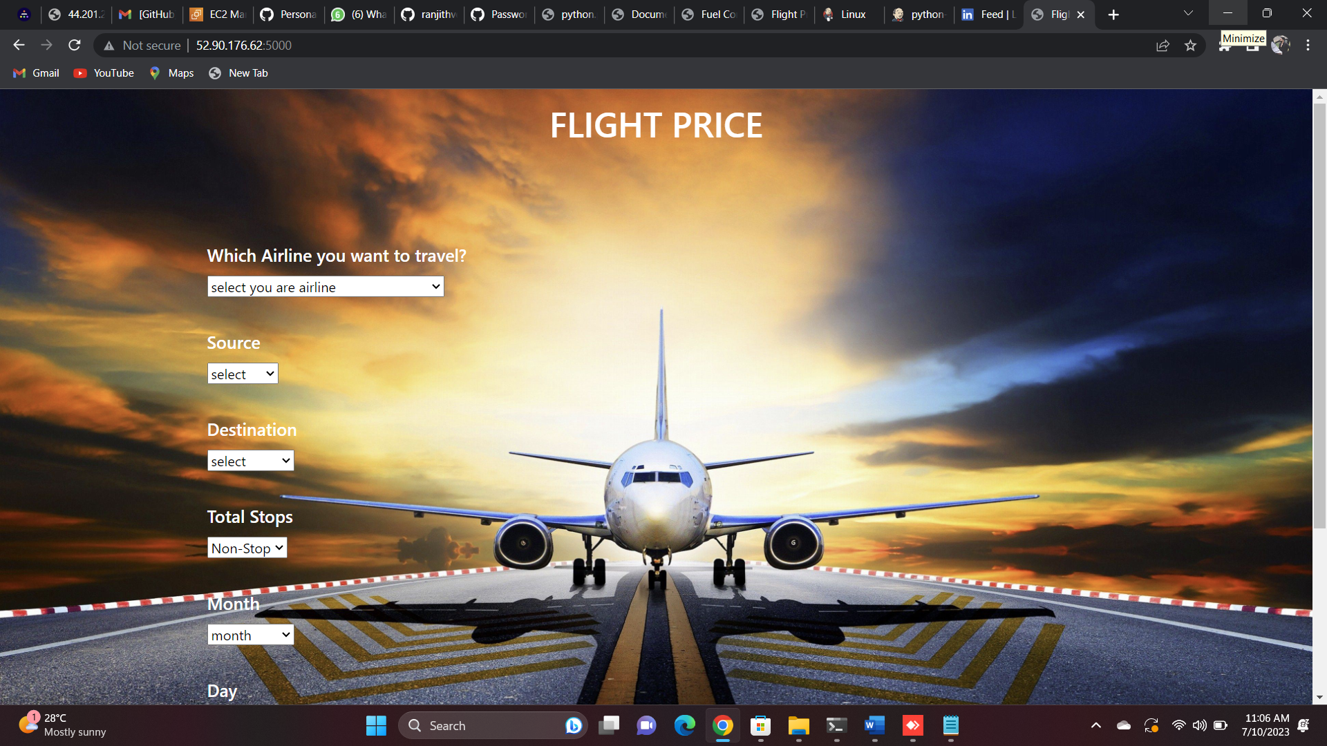

**PART 4 – Create and install Jenkins. Use terraform file to test, build and deploy application, browse the same in the browser.**

1.Create EC2 instance and install Jenkins to test, build and deploy the application.

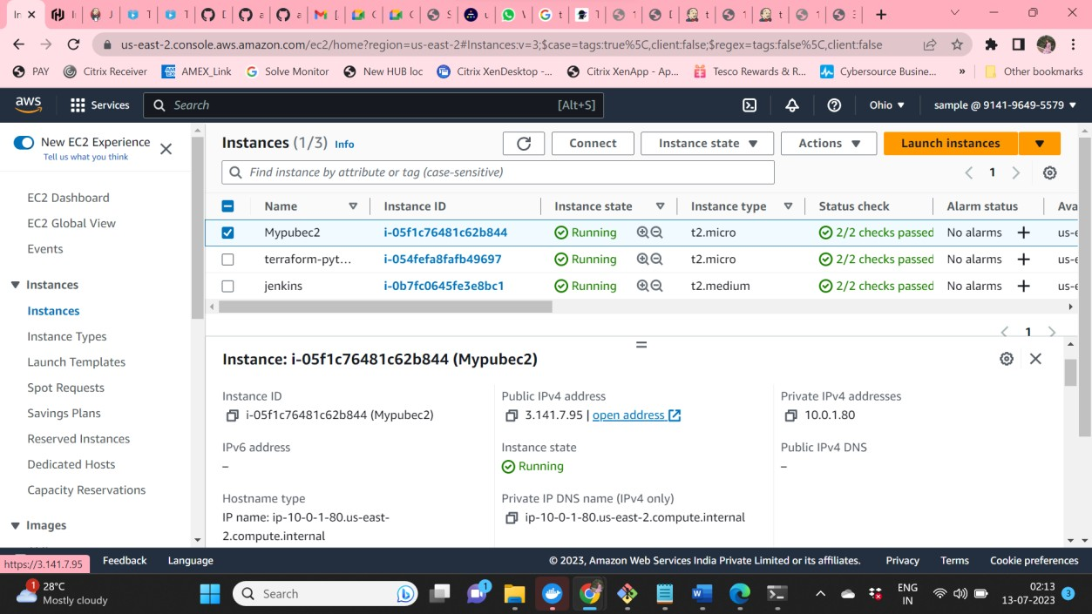

2.Create data.sh file and push it in a private repo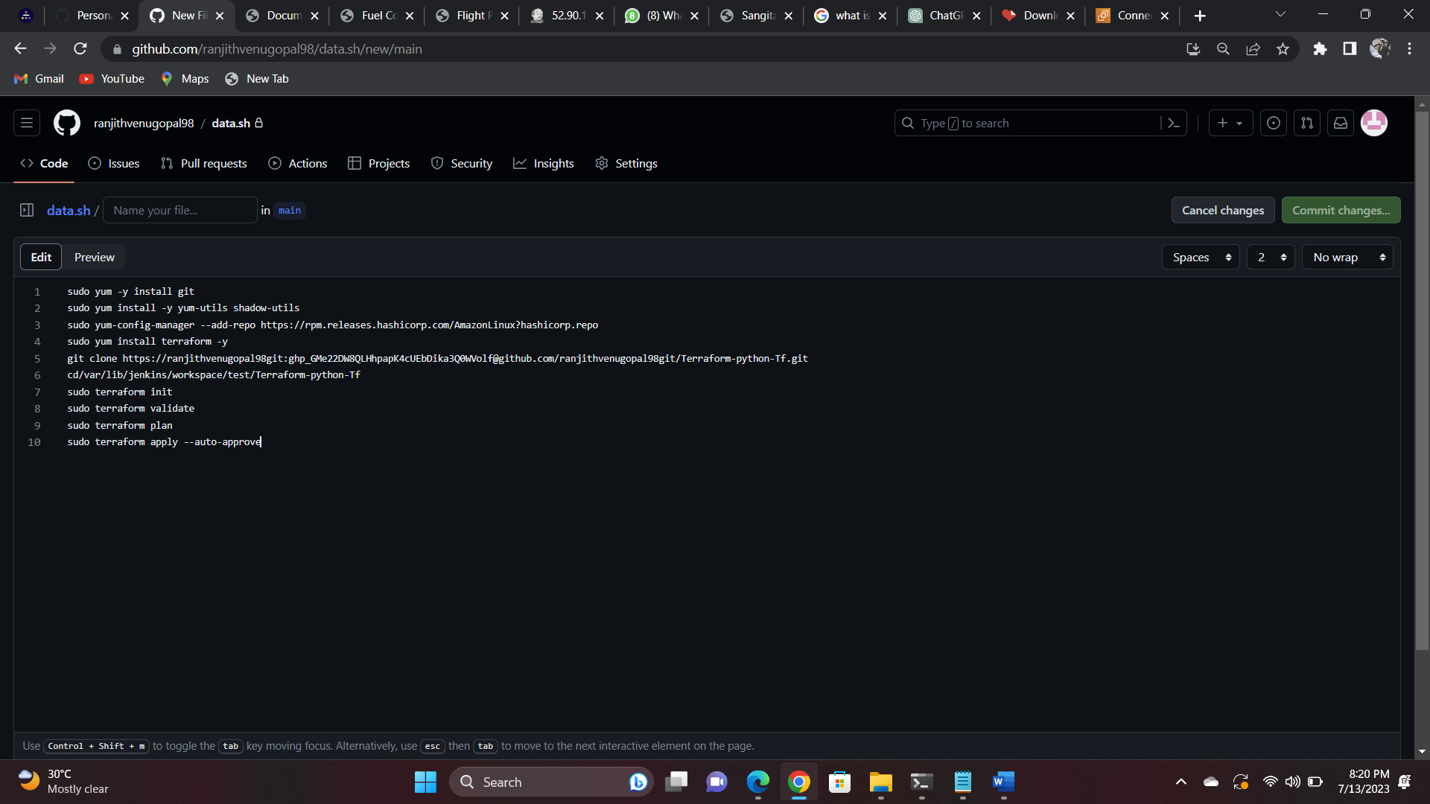

3.Creating Jenkins job to test, build and deploy 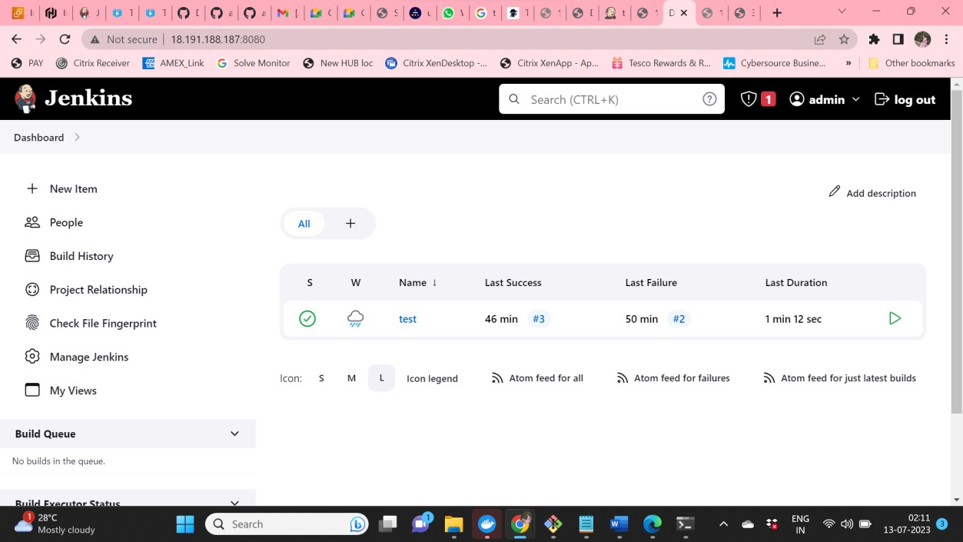

4. Provide the git repo url and shell script along with the permissions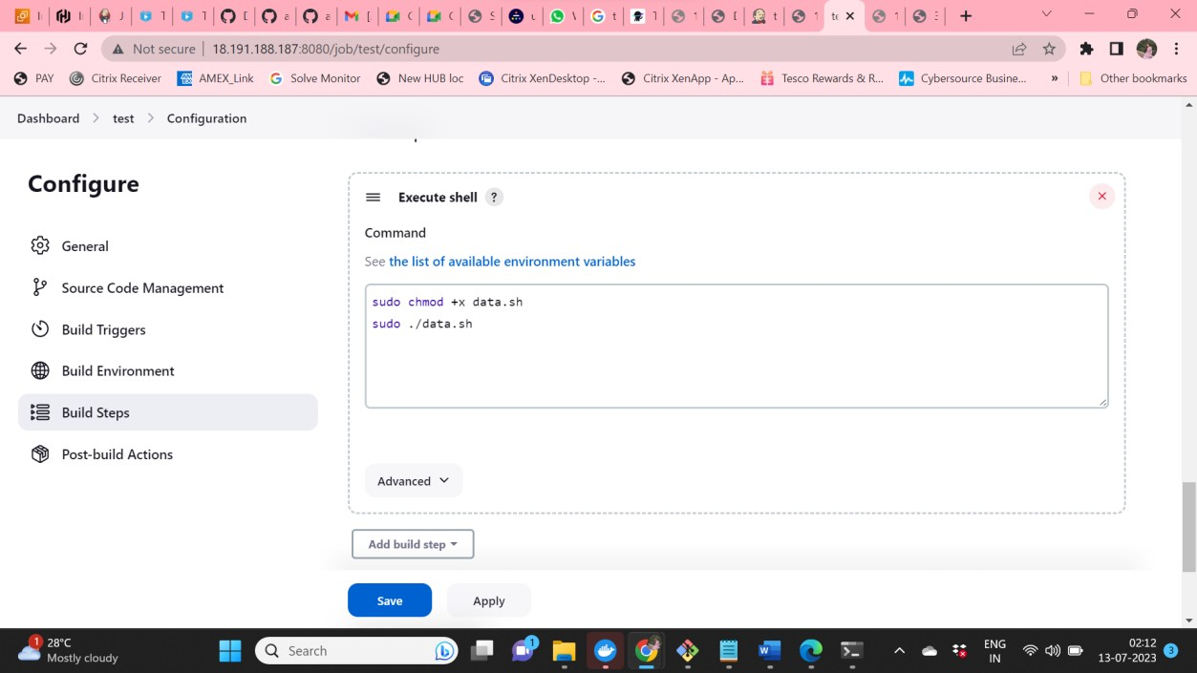

5. Validate the console output till we get success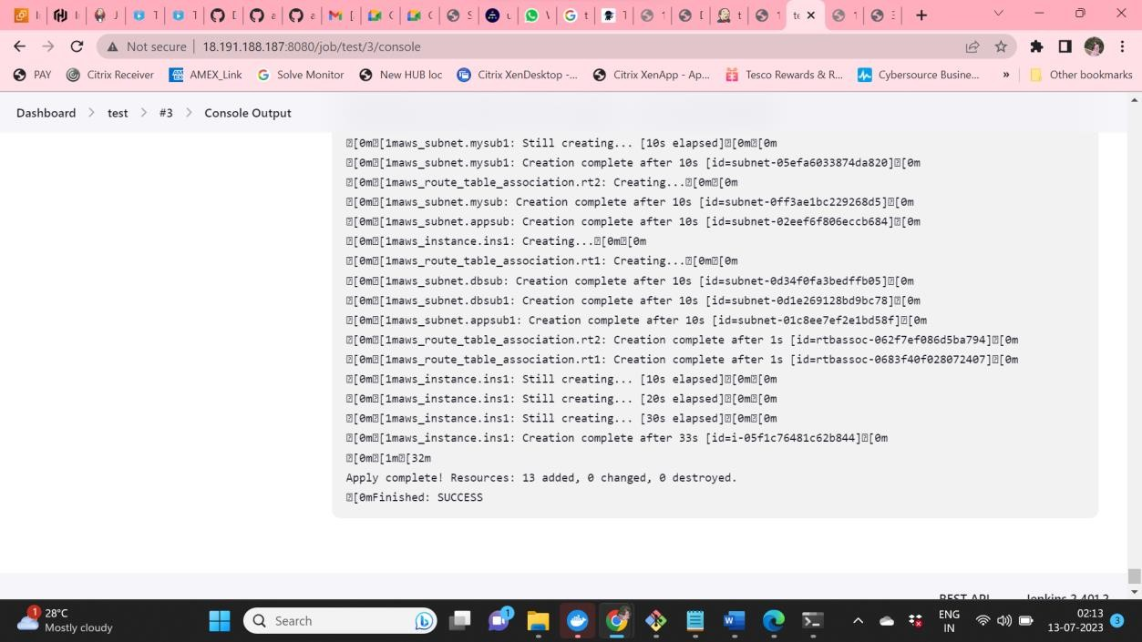

6.Browse the Public IP address and use the assigned port number to search in the web



**PART 5 – Automation using Webhooks , PollSCM and Build Periodically and validate Jenkins job is triggering or not.**

1.Create EC2 instance and install Jenkins to test, build and deploy the application. 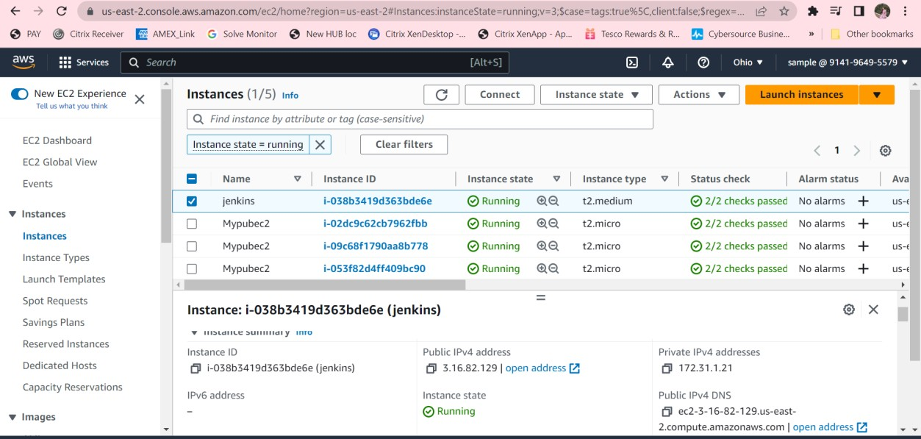

2.Install Jenkins and Create Job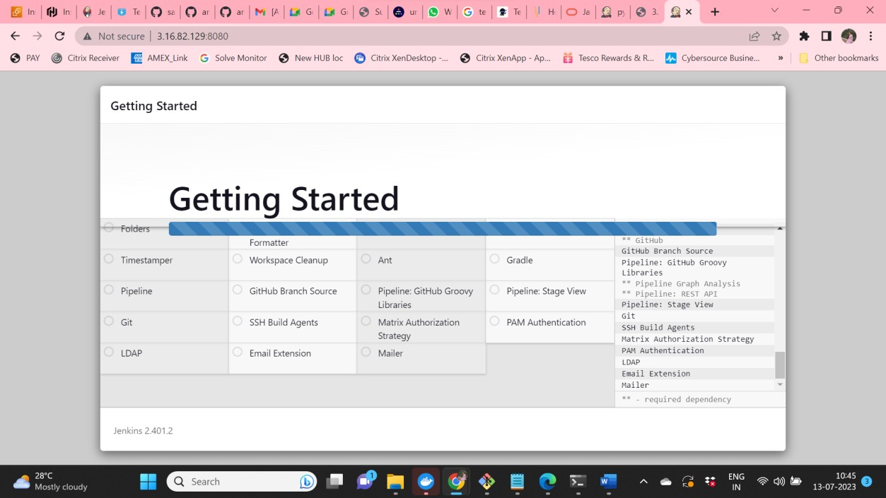

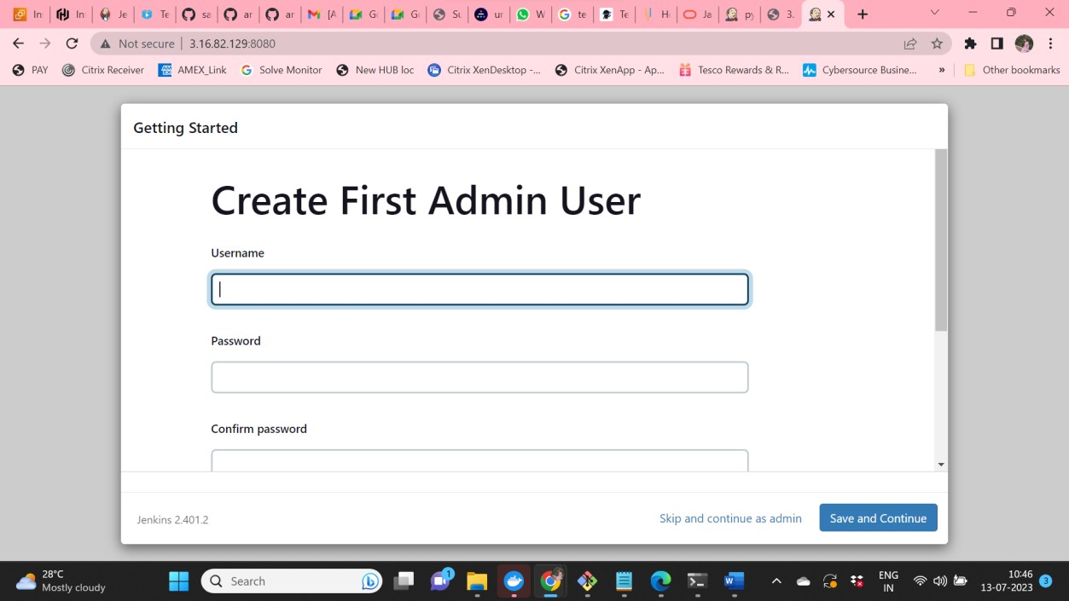

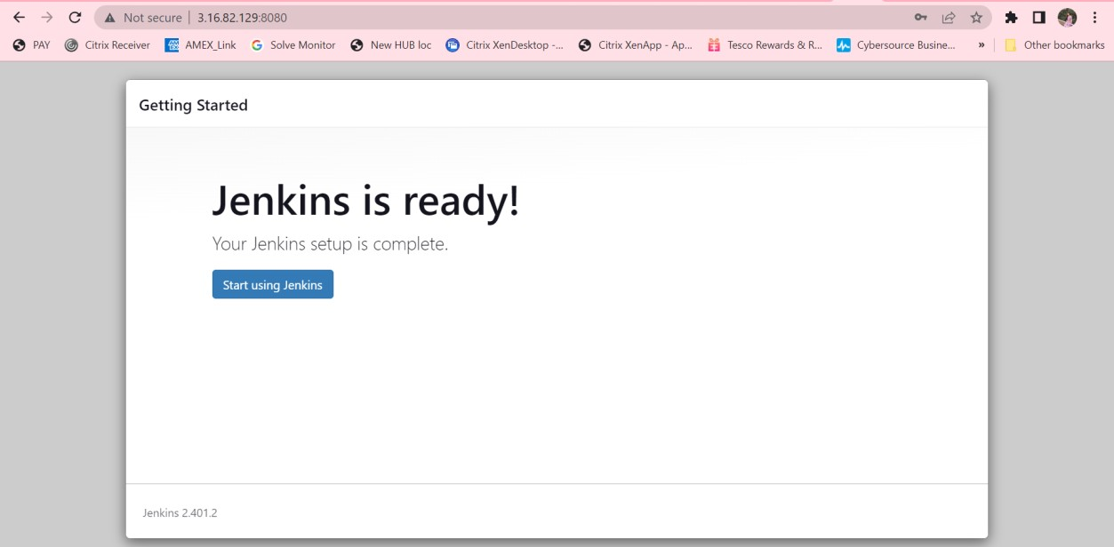

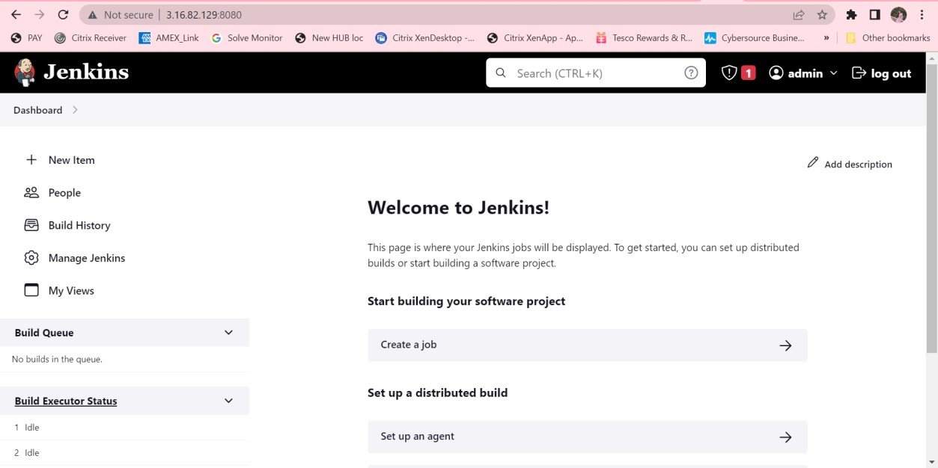

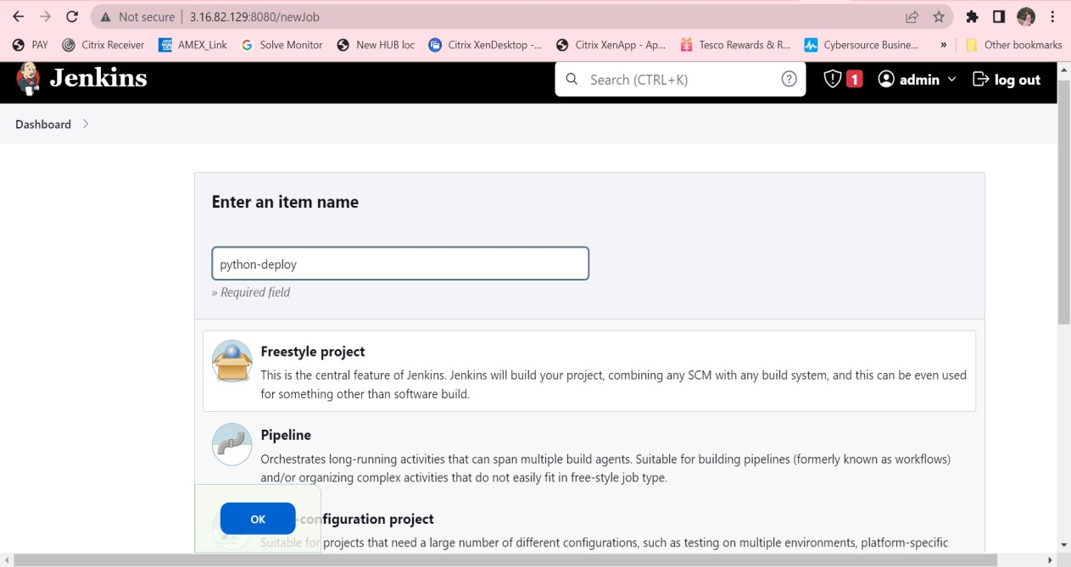

3. GitHub hook trigger for GITSCM pooling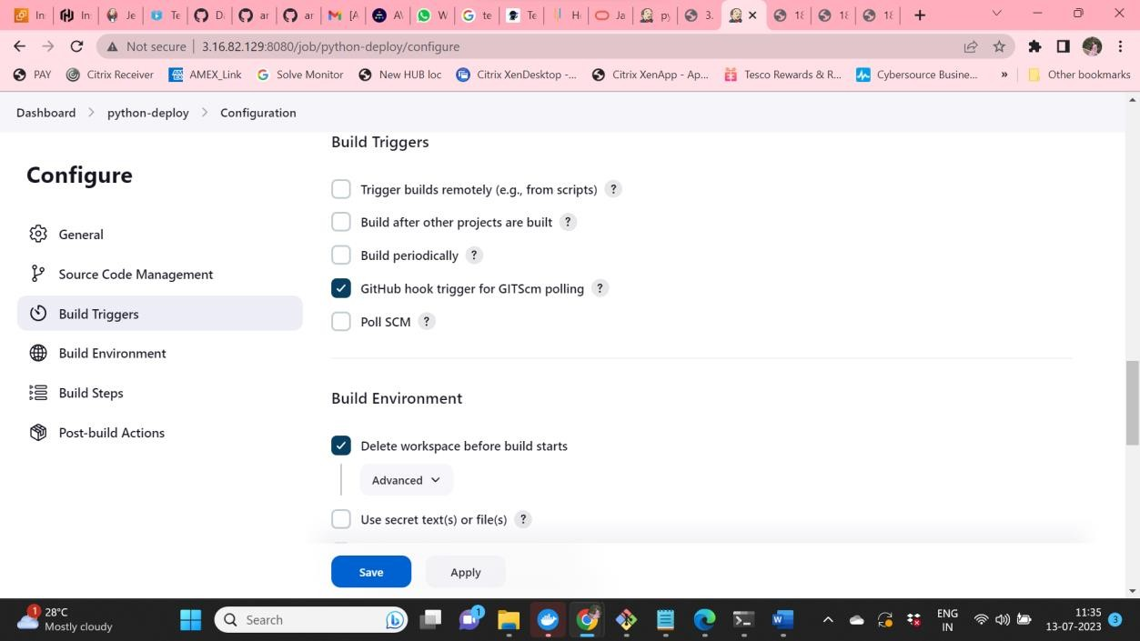

4. Provide the shell script along with the permissions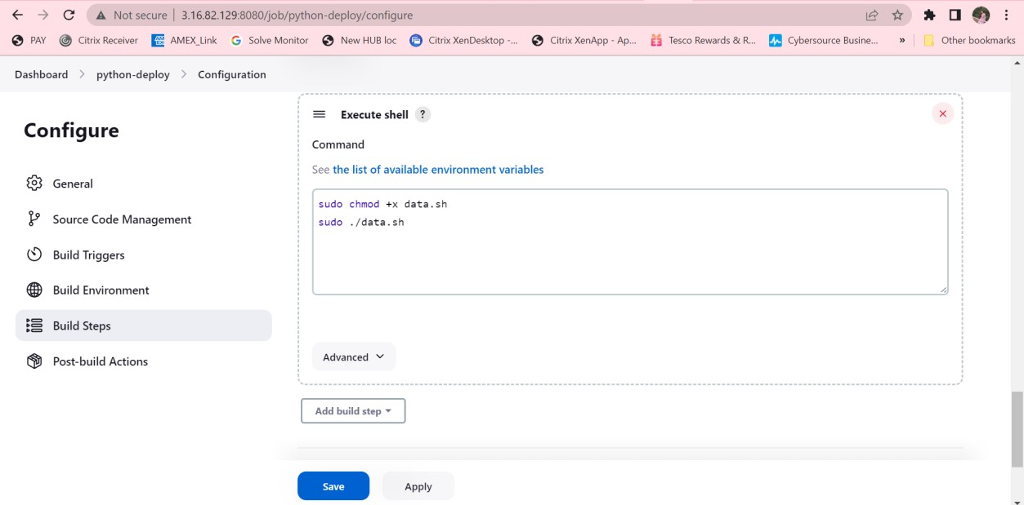

5.Job execution using Webhook



6. Job execution initiated by the admin for time span of 2 mins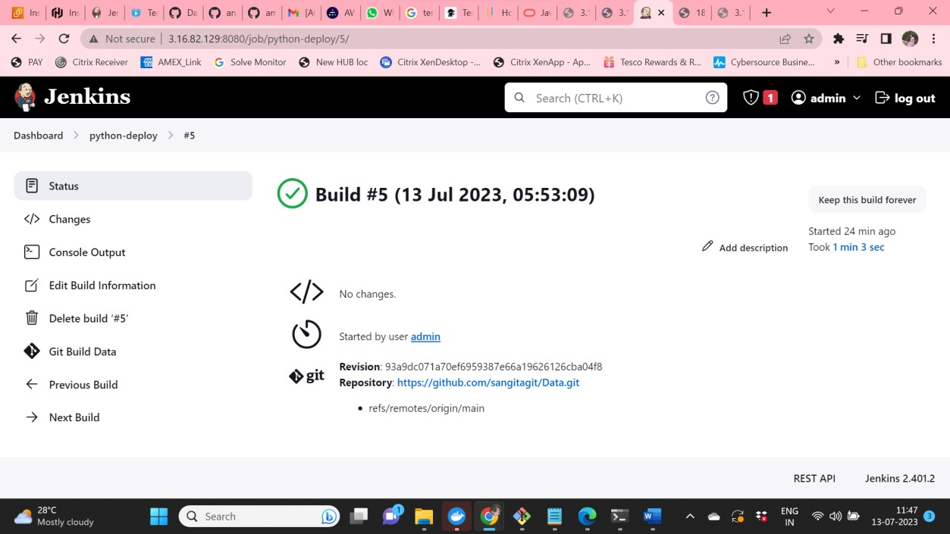

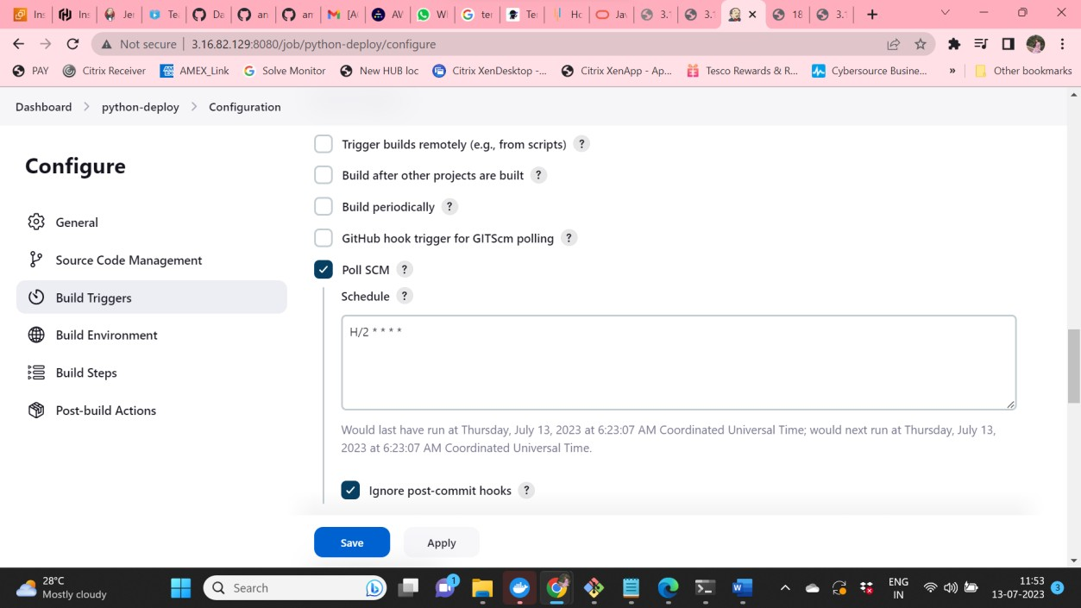

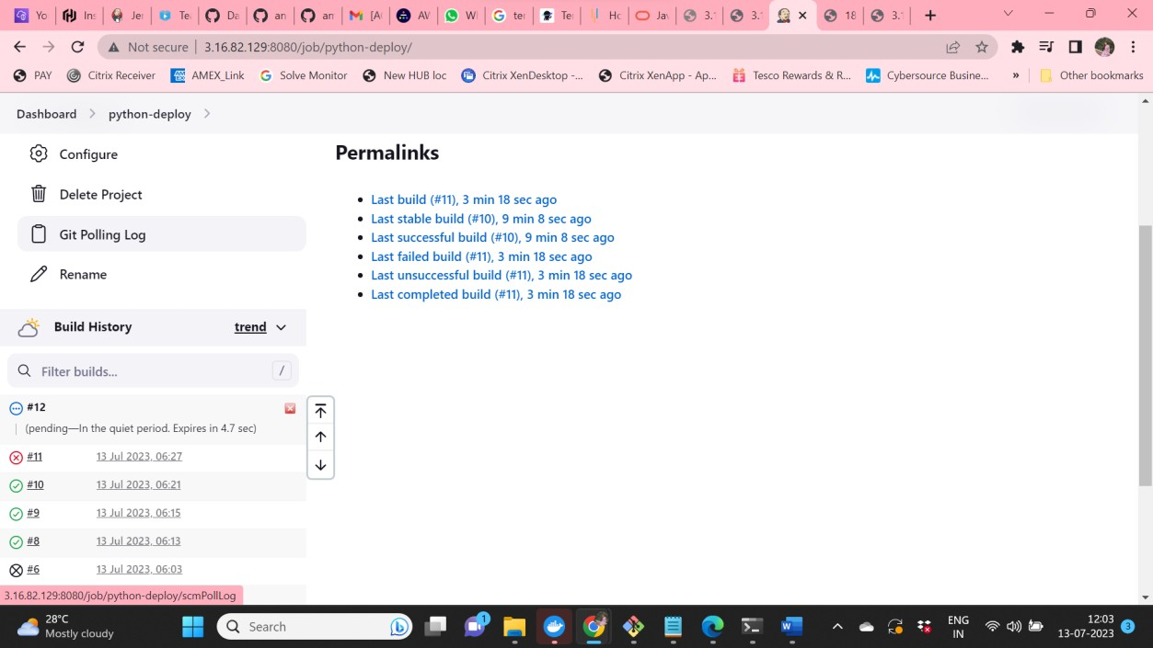

7. Job execution executed using SCM change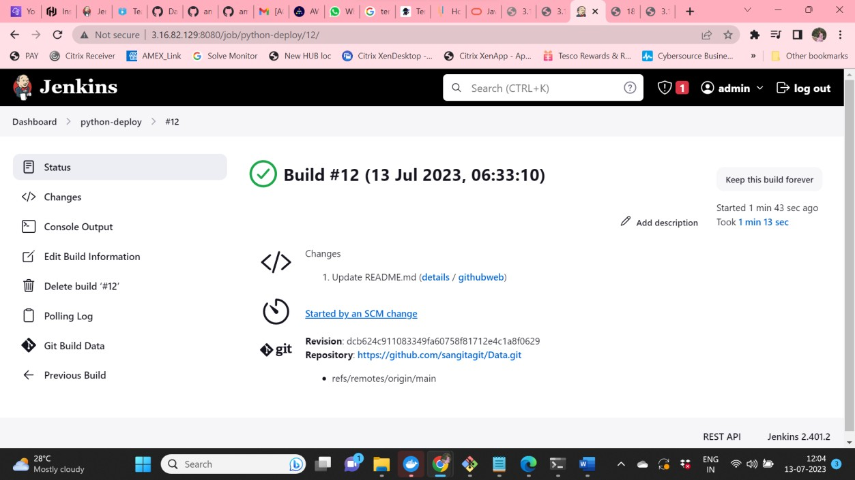

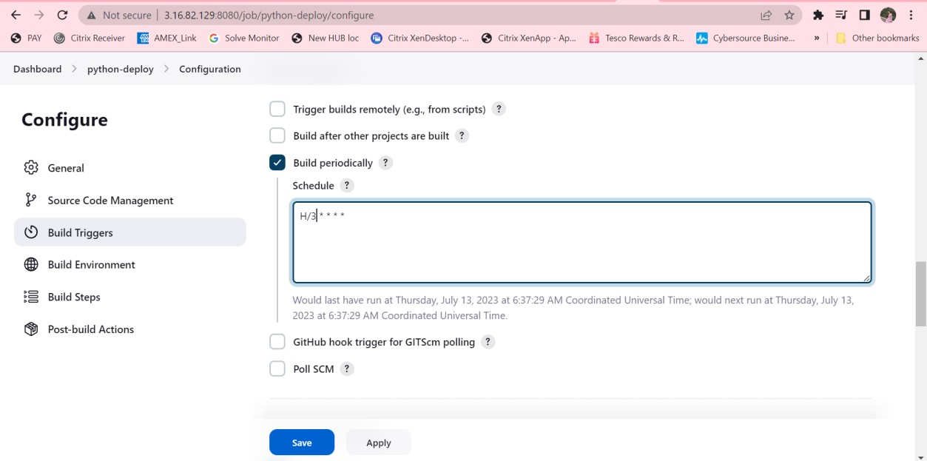

8. Modified Readme file for auto execution of Jenkins job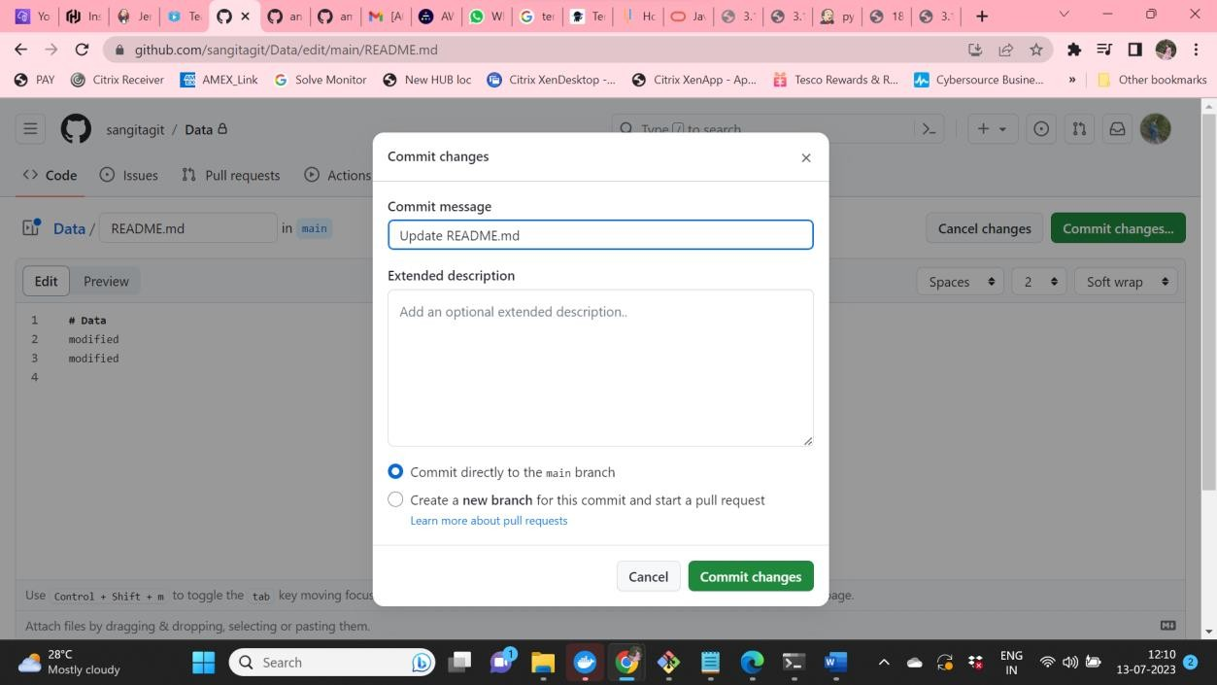

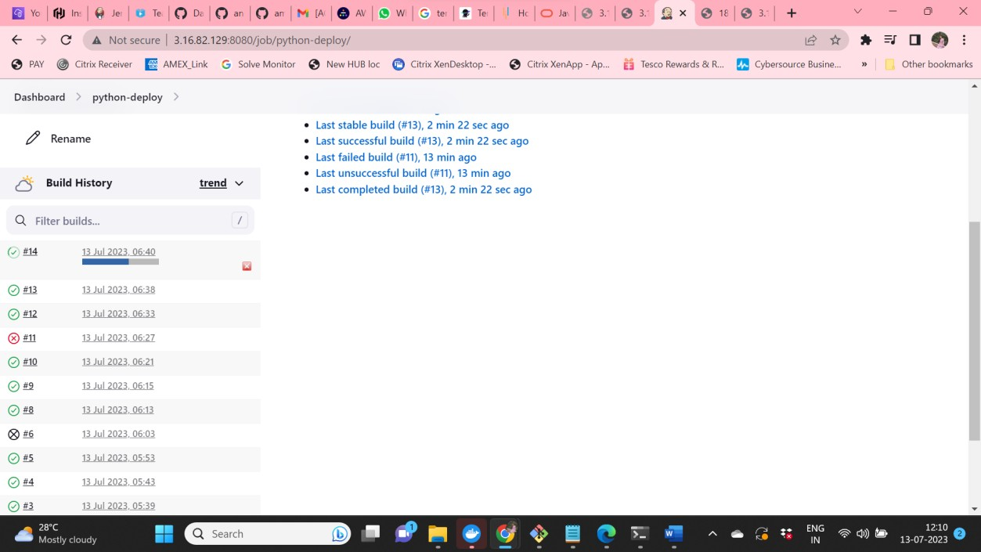

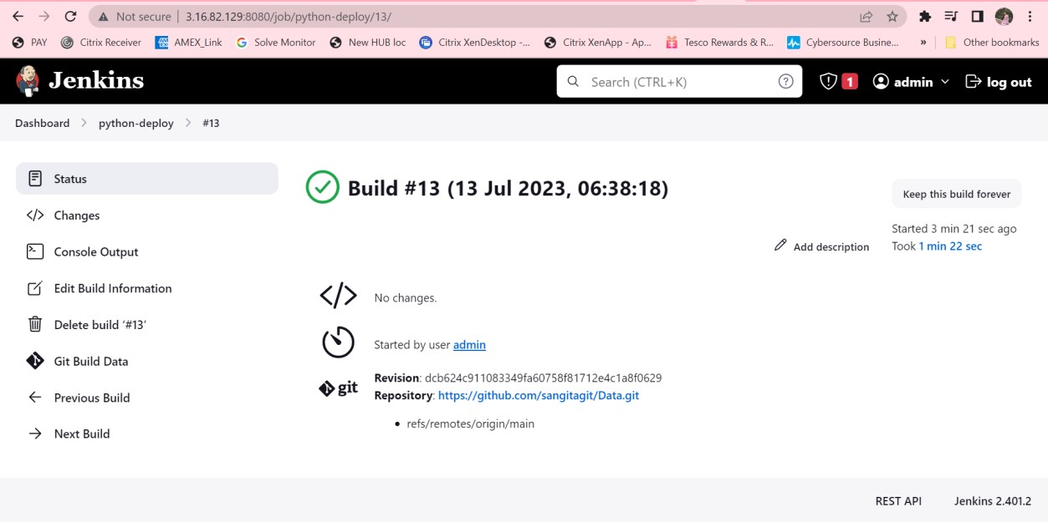

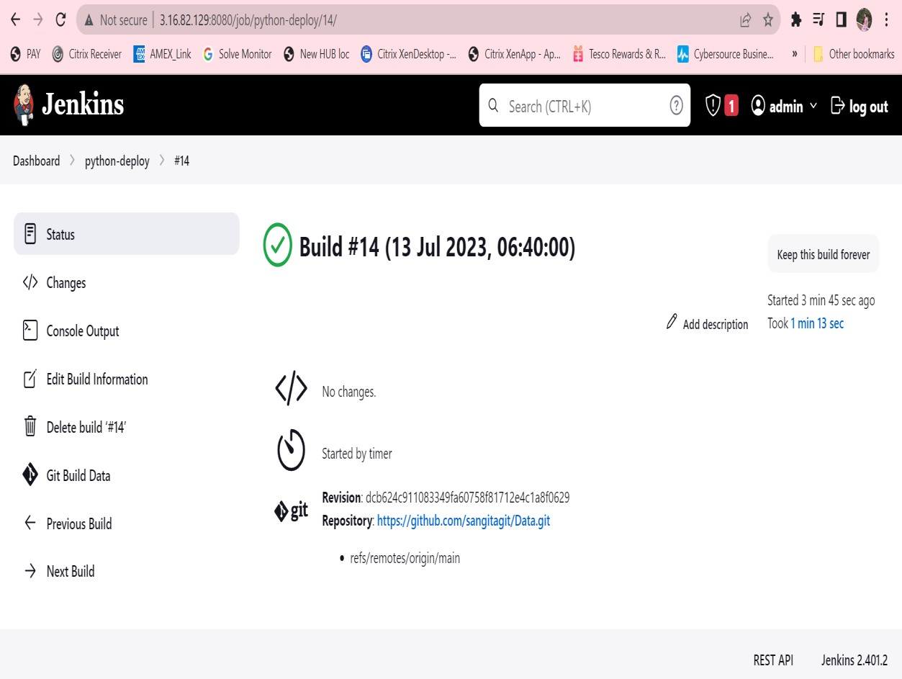

9.Browse the Public IP address and use the assigned port number to search in the web 